A

Minor Project Report

on

**DHA – A Paperless Ticketing System**

Submitted in partial fulfillment of the requirements for the award of degree of

**Bachelor of Technology**

in

**Computer Engineering**

by

**Yugant**

**(17001003064)**

Under supervision of

**Dr. Piyush Gupta**



**Department of Computer Engineering**

**J. C. BOSE UNIVERSITY OF SCIENCE & TECHNOLOGY, YMCA**

**FARIDABAD-121006**

**May 2020**

**CANDIDATE’S DECLARATION**

I hereby certify that the work which is being carried out in this Minor Project titled **“DHA – A Paperless Ticketing System”** in fulfillment of the requirement for the degree of Bachelor of Technology in Computer Engineering and submitted to “**J. C. Bose** **University of Science and Technology, YMCA, Faridabad**”*,* is an authentic record of my own work carried out under the supervision of Dr.ATUL MISHRA.

The work contained in this thesis has not been submitted to any other University or Institute for the award of any other degree or diploma by me.

Yugant

17001003064

**CERTIFICATE**

This is to certify that the work carried out in this project titled **“DHA – A Paperless Ticketing System ”** submitted by Yugant to “**J. C. Bose** **University of Science and Technology, YMCA, Faridabad**” for the award of the degree of Bachelor of Technology in Computer Engineering is a record of bonafide work carried out by her under my supervision. In my opinion, the submitted report has reached the standards of fulfilling the requirements of the regulations to the degree.

Dr. ATUL MISHRA

(Supervisor)

Assistant Professor,

Department of Computer Engg,

J. C. Bose University of Science and Technology, YMCA, Faridabad

Dr. Komal Kumar Bhatia

Chairman,

Department of Computer Engg,

J. C. Bose University of Science and Technology, YMCA, Faridabad

**TABLE OF CONTENTS**

CANDIDATE’S DECLARATION ii

CERTIFICATE iii

**CHAPTER 1: INTRODUCTION**  **1-4**

1.1 Introduction 1

1.2 Basic Terminology 2

1.2.1 Face Recognition 2

1.2.2 Django 3

1.2.3 Dynamic Human Authentication 3

1.3 Motivation for the Project 3

1.4 Objectives and Scope 4

**CHAPTER 2: LITERATURE REVIEW 5-10**

* 1. Histogram of Oriented Gradient
  2. Convolution Neural Network
  3. Deep Neural Network
  4. Facial Landmarks
  5. Embeddings
  6. Support Vector Machine
  7. Dlib
  8. Opencv

**CHAPTER 3: DESCRIPTION & METHODOLOGY 11-36**

**CHAPTER 4: HARDWARE AND SOFTWARE REQUIREMENTS 37**

**CHAPTER 5: RESULTS 38-39**

**CHAPTER 6: CONCLUSION 40**

**REFERENCES 41**

**CHAPTER 1: INTRODUCTION**

**1.1 INTRODUCTION**

Time and convenience have great importance in human life. Traditional ticketing system is not much efficient. In traditional ticketing system one has to always carry money with them and wait in queues in order to book tickets Even in metro rail one has to punch card and wait in queues in order to wait for their turn. It takes a lot of time and resources in order to manage these things and give user a satisfactory user system.

Paper tickets with barcodes are used as entry and exit pass for rail transport.

The drawbacks of the traditional ticketing system are as follows:-

* Inconvenience for safe keeping of paper tickets
* Wastage of paper
* Time consuming

We can tackle this problem by a paperless ticketing system using face recognition by identifying and analysing the shape of a person’s face. Each face has approximately 68 unique nodal points called facial landmarks which distinguishes one from another. It can be used to identify an individual face as one’s face is one of the easiest ways to distinguish the individual identity of person. In this project we plan to use Face recognition to implement a Paperless ticketing system.

**1.2 BASIC TERMINOLOGY**

**1.2.1 Face Recognition**

A facial recognition system is a technology capable of identifying or verifying a person from a digital image or a video frame from a video source. There are multiple methods in which facial recognition systems work, but in general, they work by comparing selected facial features from given image with faces within a database. It is also described as a Biometric Artificial Intelligence based application that can uniquely identify a person by analysing patterns based on the person's facial textures and shape.

While initially a form of computer application, it has seen wider uses in recent times on mobile platforms and in other forms of technology, such as robotics. It is typically used as access control in security systems and can be compared to other biometrics such as fingerprint or eye iris recognition systems. Although the accuracy of facial recognition system as a biometric technology is lower than iris recognition and fingerprint recognition, it is widely adopted due to its contactless and non-invasive process. Recently, it has also become popular as a commercial identification and marketing tool. Other applications include advanced human-computer interaction, video surveillance, automatic indexing of images, and video database, among others.

**1.2.2 Django**

Django is a [Python](https://en.wikipedia.org/wiki/Python_(programming_language))-based [free and open-source](https://en.wikipedia.org/wiki/Free_and_open-source_software) [web framework](https://en.wikipedia.org/wiki/Web_framework) that follows the [model-template-view](https://en.wikipedia.org/wiki/Model-template-view) (MTV) [architectural pattern](https://en.wikipedia.org/wiki/Architectural_pattern_(computer_science)). It is maintained by the [Django Software Foundation](https://en.wikipedia.org/wiki/Django_Software_Foundation) (DSF), an American independent organization established as a [501](https://en.wikipedia.org/wiki/501(c)(3)) non-profit.

Django's primary goal is to ease the creation of complex, database-driven websites. The framework emphasizes [reusability](https://en.wikipedia.org/wiki/Reusability) and "pluggability" of components, less code, low coupling, rapid development, and the principle of [don't repeat yourself](https://en.wikipedia.org/wiki/Don%27t_repeat_yourself). Python is used throughout, even for settings files and data models. Django also provides an optional administrative [create, read, update and delete](https://en.wikipedia.org/wiki/Create,_read,_update_and_delete) interface that is generated dynamically through [introspection](https://en.wikipedia.org/wiki/Type_introspection) and configured via admin models.

Some well-known sites that use Django include Instagram, Mozilla, The Washington Times.

**1.2.3 Dynamic Human Authentication**

As confirmed by recent neurophysiological studies, the use of dynamic information is extremely important for humans in visual perception of biological forms and motion. Apart from the mere computation of the visual motion of the viewed objects, the motion itself conveys far more information, which helps understanding the scene. This paper provides an overview and some new insights on the use of dynamic visual information for face recognition. In this context, not only physical features emerge in the face representation, but also behavioral features should be accounted. While physical features are obtained from the subject’s face appearance, behavioral features are obtained from the individual motion and articulation of the face. In order to capture both the face appearance and the face dynamics, a dynamical face model based on a combination of Hidden Markov Models is presented. The number of states (or facial expressions) are automatically determined from the data by unsupervised clustering of expressions of faces in the video. The underlying architecture closely recalls the neural patterns activated in the perception of moving faces. Experimental results obtained from real video image data show the feasibility of the proposed approach.

* 1. **MOTIVATION**

As the number of travelers increase exponentially, we need to think of way to make the process of travel easy and convenient for people. Long waiting queues for tickets and verification passage consumes a lot of time. An individual also has to carry money with them in order to process to transaction. There is a risk of that person being pickpocketed.

There are static user authentication systems but it has the following drawbacks:-

* A person has to individually stand in front of camera to get access and wastes 1 min (approx.)
* It can’t cover a large entrance
* It can be easily surpassed as with single authorization more than 1-2 people can enter if move rapidly.

In order to make it work in much optimal way we implemented Dynamic Human Authentication.

* 1. **OBJECTIVES AND SCOPE**

With the static authentication having those drawbacks, the need of the hour is todo the same process of authentication in a much optimized way, which can be done via dynamic user authentication system.

It can easily detect a group of people until the faces are hidden and can cover a large entrance.

Data recorded is also being used to train the model without pausing (Manual or frequent)

Upper Body Detection would also be used for more accuracy for detection only.

Advantages:-

* Convenient
* Eco-friendly
* Time saving

By using dynamic human authentication system the time to authenticate an individual will reduce to a great extent. Since it performs authentication in real time therefore its field of vision will be large as compared to static authentication. It will make the travel much more convenient than the traditional method with used bar code and paper. Consumption of paper would be reduced and that would benefit the environment.

**CHAPTER 2: LITERATURE REVIEW**

**2.1 HISTOGRAM OF ORIENTED GRADIENT**

The histogram of oriented gradients (HOG) is a feature descriptor used in computer vision and image processing for the purpose of object detection. The technique counts occurrences of gradient orientation in localized portions of an image. This method is similar to that of edge orientation histograms, scale-invariant feature transform descriptors, and shape contexts, but differs in that it is computed on a dense grid of uniformly spaced cells and uses overlapping local contrast normalization for improved accuracy. Robert K. McConnell of Wayland Research Inc. first described the concepts behind HOG without using the term HOG in a patent application in 1986. In 1994 the concepts were used by Mitsubishi Electric Research Laboratories. However, usage only became widespread in 2005 when Navneet Dalal and Bill Triggs, researchers for the French National Institute for Research in Computer Science and Automation (INRIA), presented their supplementary work on HOG descriptors at the Conference on Computer Vision and Pattern Recognition (CVPR). In this work they focused on pedestrian detection in static images, although since then they expanded their tests to include human detection in videos, as well as to a variety of common animals and vehicles in static imagery. The essential thought behind the histogram of oriented gradients descriptor is that local object appearance and shape within an image can be described by the distribution of intensity gradients or edge directions. The image is divided into small connected regions called cells, and for the pixels within each cell, a histogram of gradient directions is compiled. The descriptor is the concatenation of these histograms. For improved accuracy, the local histograms can be contrast-normalized by calculating a measure of the intensity across a larger region of the image, called a block, and then using this value to normalize all cells within the block. This normalization results in better invariance to changes in illumination and shadowing. The HOG descriptor has a few key advantages over other descriptors. Since it operates on local cells, it is invariant to geometric and photometric transformations, except for object orientation. Such changes would only appear in larger spatial regions. Moreover, as Dalal and Triggs discovered, coarse spatial sampling, fine orientation sampling, and strong local photometric normalization permits the individual body movement of pedestrians to be ignored so long as they maintain a roughly upright position. The HOG descriptor is thus particularly suited for human detection in images.

**2.2 CONVOLUTION NEURAL NETWORK**

In deep learning, a convolutional neural network (CNN, or ConvNet) is a class of deep neural networks, most commonly applied to analyzing visual imagery. They are also known as shift invariant or space invariant artificial neural networks (SIANN), based on their shared-weights architecture and translation invariance characteristics.

A convolutional neural network consists of an input and an output layer, as well as multiple hidden layers. The hidden layers of a CNN typically consist of a series of convolutional layers that convolve with a multiplication or other dot product. The activation function is commonly a RELU layer, and is subsequently followed by additional convolutions such as pooling layers, fully connected layers and normalization layers, referred to as hidden layers because their inputs and outputs are masked by the activation function and final convolution. Though the layers are colloquially referred to as convolutions, this is only by convention. Mathematically, it is technically a sliding dot product or cross-correlation. This has significance for the indices in the matrix, in that it affects how weight is determined at a specific index point. They have applications in image and video recognition, recommender systems, image classification, medical image analysis, natural language processing, and financial time series. CNNs are regularized versions of multilayer perceptrons. Multilayer perceptrons usually mean fully connected networks, that is, each neuron in one layer is connected to all neurons in the next layer. The “fully-connectedness” of these networks makes them prone to overfitting data. Typical ways of regularization include adding some form of magnitude measurement of weights to the loss function. CNNs take a different approach towards regularization: they take advantage of the hierarchical pattern in data and assemble more complex patterns using smaller and simpler patterns. Therefore, on the scale of connectedness and complexity, CNNs are on the lower extreme. Convolutional networks were inspired by biological processes in that the connectivity pattern between neurons resembles the organization of the animal visual cortex. Individual cortical neurons respond to stimuli only in a restricted region of the visual field known as the receptive field. The receptive fields of different neurons partially overlap such that they cover the entire visual field. CNNs use relatively little pre-processing compared to other image classification algorithms. This means that the network learns the filters that in traditional algorithms were hand-engineered. This independence from prior knowledge and human effort in feature design is a major advantage.

**2.3 DEEP NEURAL NETWORK**

Deep learning is a class of machine learning algorithms that(pp199–200) uses multiple layers to progressively extract higher level features from the raw input. For example, in image processing, lower layers may identify edges, while higher layers may identify the concepts relevant to a human such as digits or letters or faces. Deep learning (also known as deep structured learning) is part of a broader family of machine learning methods based on artificial neural networks with representation learning. Learning can be supervised, semi-supervised or unsupervised. Deep learning architectures such as deep neural networks, deep belief networks, recurrent neural networks and convolutional neural networks have been applied to fields including computer vision, speech recognition, natural language processing, audio recognition, social network filtering, machine translation, bioinformatics, drug design, medical image analysis, material inspection and board game programs, where they have produced results comparable to and in some cases surpassing human expert performance. Artificial neural networks (ANNs) were inspired by information processing and distributed communication nodes in biological systems. ANNs have various differences from biological brains. Specifically, neural networks tend to be static and symbolic, while the biological brain of most living organisms is dynamic (plastic) and analog. The adjective "deep" in deep learning comes from the use of multiple layers in the network. Early work showed that a linear perceptron cannot be a universal classifier, and then that a network with a non polynomial activation function with one hidden layer of unbounded width can on the other hand so be. Deep learning is a modern variation which is concerned with an unbounded number of layers of bounded size, which permits practical application and optimized implementation, while retaining theoretical universality under mild conditions. In deep learning the layers are also permitted to be heterogeneous and to deviate widely from biologically informed connectionist models, for the sake of efficiency, trainability and understandability, whence the "structured" part.

**2.4 FACIAL LANDMARKS**

Facial landmarks are used to localize and represent salient regions of the face, such as: Eyes, Eyebrows, Nose, Mouth, Jawline, Facial landmarks have been successfully applied to face alignment, head pose estimation, face swapping, blink detection and much more. Face detection can be achieved in a number of ways. We could use OpenCV’s built-in Haar cascades. We might apply a pre-trained HOG + Linear SVM object detector specifically for the task of face detection. Or we might even use deep learning-based algorithms for face localization. In either case, the actual algorithm used to detect the face in the image doesn’t matter. Instead, what’s important is that through some method we obtain the face bounding box (i.e., the (x, y)-coordinates of the face in the image).

**2.5 EMBEDDINGS**

The simplest approach to face recognition is to directly compare the unknown face we found with all the pictures we have of people that have already been tagged. When we find a previously tagged face that looks very similar to our unknown face, it must be the same person. Seems like a pretty good idea, right? There’s actually a huge problem with that approach. A site like Facebook with billions of users and a trillion photos can’t possibly loop through every previous-tagged face to compare it to every newly uploaded picture. That would take way too long. They need to be able to recognize faces in milliseconds, not hours. What we need is a way to extract a few basic measurements from each face. Then we could measure our unknown face the same way and find the known face with the closest measurements. For example, we might measure the size of each ear, the spacing between the eyes, the length of the nose, etc. The solution is to train a Deep Convolutional Neural. But instead of training the network to recognize pictures objects, we are going to train it to generate 128 measurements for each face. The training process works by looking at 3 face images at a time: Load a training face image of a known person, Load another picture of the same known person and Load a picture of a totally different person. Then the algorithm looks at the measurements it is currently generating for each of those three images. It then tweaks the neural network slightly so that it makes sure the measurements it generates for #1 and #2 are slightly closer while making sure the measurements for #2 and #3 are slightly further apart: After repeating this step millions of times for millions of images of thousands of different people, the neural network learns to reliably generate 128 measurements for each person. Any ten different pictures of the same person should give roughly the same measurements. Machine learning people call the 128 measurements of each face an embedding. The idea of reducing complicated raw data like a picture into a list of computer-generated numbers comes up a lot in machine learning (especially in language translation). The exact approach for faces we are using was invented in 2015 by researchers at Google but many similar approaches exist. This process of training a convolutional neural network to output face embeddings requires a lot of data and computer power. Even with an expensive NVidia Telsa video card, it takes about 24 hours of continuous training to get good accuracy. But once the network has been trained, it can generate measurements for any face, even ones it has never seen before! So this step only needs to be done once.

**2.6 SUPPORT VECTOR MACHINE**

In machine learning, support-vector machines (SVMs, also support-vector networks) are supervised learning models with associated learning algorithms that analyze data used for classification and regression analysis. Given a set of training examples, each marked as belonging to one or the other of two categories, an SVM training algorithm builds a model that assigns new examples to one category or the other, making it a non-probabilistic binary linear classifier (although methods such as Platt scaling exist to use SVM in a probabilistic classification setting). An SVM model is a representation of the examples as points in space, mapped so that the examples of the separate categories are divided by a clear gap that is as wide as possible. New examples are then mapped into that same space and predicted to belong to a category based on the side of the gap on which they fall. In addition to performing linear classification, SVMs can efficiently perform a non-linear classification using what is called the kernel trick, implicitly mapping their inputs into high-dimensional feature spaces. When data are unlabelled, supervised learning is not possible, and an unsupervised learning approach is required, which attempts to find natural clustering of the data to groups, and then map new data to these formed groups. The support-vector clustering algorithm, created by Hava Siegelmann and Vladimir Vapnik, applies the statistics of support vectors, developed in the support vector machines algorithm, to categorize unlabeled data, and is one of the most widely used clustering algorithms in industrial applications.

**2.7 DLIB**

Dlib is a modern C++ toolkit containing machine learning algorithms and tools for creating complex software in C++ to solve real world problems. It is used in both industry and academia in a wide range of domains including robotics, embedded devices, mobile phones, and large high performance computing environments. Dlib's open source licensing allows you to use it in any application, free of charge. Its design is heavily influenced by ideas from design by contract and component-based software engineering. Thus it is, first and foremost, a set of independent software components. It is open-source software released under a Boost Software License. Since development began in 2002, Dlib has grown to include a wide variety of tools. As of 2016, it contains software components for dealing with networking, threads, graphical user interfaces, data structures, linear algebra, machine learning, image processing, data mining, XML and text parsing, numerical optimization, Bayesian networks, and many other tasks. In recent years, much of the development has been focused on creating a broad set of statistical machine learning tools and in 2009 Dlib was published in the Journal of Machine Learning Research.[2] Since then it has been used in a wide range of domains

**2.8 OPENCV**

OpenCV (Open Source Computer Vision Library) is a library of programming functions mainly aimed at real-time computer vision. Originally developed by Intel, it was later supported by Willow Garage then Itseez (which was later acquired by Intel). The library is cross-platform and free for use under the open-source BSD license.

**CHAPTER 3: DESCRIPTION AND METHODOLOGY**

In this section, the overall working of the project has been described. How the project started and how the project works and how the various phases of project were carried out and the challenges faced at each level.

**3.1 WHAT DOES THE PROJECT DO?**

The project as, the name suggests is a face recognition project. The main function of the project is to identify individuals and show whether the user is a registered user or not. If the user is a registered one then he/she can travel freely and when they reach their destination their log will be filled with all the values present in the log like entry station, exit station, person id etc. A mail would be sent to the traveler so that he/she can use it to maintain his/her travel history. If the user is not a registered one then unknown would be shown instead of their name with -1 as their person id. They would be stopped and asked to register if they want to use the travel facilities.

The main benefit of the project is that, dynamic user authentication would be done in real time. It would lead to less time in queue and make travel much convenient. Multiple users can be authenticated in the given window which would improve more depending upon the performance of the machine and the model used. The model used is a pre trained one with accuracy of over 99%, as a result only a few number of photos is enough to identify an individual. Even if the traveler changes their hairstyle or facial hair or wear a cap they could be identified.

The logs are visible to the administrator. If the traveler has exited from a station only then their exit station value will be present else it will be set to NULL which is initially. The administrator has the record of the traveler with their id, station name with their id and logs of the traveler with their travel record.

**3.2 WORKING OF THE FACE RECOGNITION MODEL**

Face recognition is really a series of several related problems:

* First, look at a picture and find all the faces in it.
* Second, focus on each face and be able to understand that even if a face is turned in a weird direction or in bad lighting, it is still the same person.
* Third, be able to pick out unique features of the face that you can use to tell it apart from other people— like how big the eyes are, how long the face is, etc.
* Finally, compare the unique features of that face to all the people you already know to determine the person’s name.

As a human, your brain is wired to do all of this automatically and instantly. In fact, humans are too good at recognizing faces and end up seeing faces in everyday objects.

Computers are not capable of this kind of high-level generalization (at least not yet…), so we have to teach them how to do each step in this process separately. We need to build a pipeline where we solve each step of face recognition separately and pass the result of the current step to the next step. In other words, we will chain together several machine learning algorithms.

**3.2.1 Finding all the faces**

Face detection went mainstream in the early 2000's when Paul Viola and Michael Jones invented a way to detect faces that was fast enough to run on cheap cameras. However, much more reliable solutions exist now. We’re going to use a method invented in 2005 called Histogram of Oriented Gradients — or just HOG for short. To find faces in an image, we’ll start by making our image black and white because we don’t need color data to find faces. Then we’ll look at every single pixel in our image one at a time. For every single pixel, we want to look at the pixels that directly surrounding it. Our goal is to figure out how dark the current pixel is compared to the pixels directly surrounding it. Then we want to draw an arrow showing in which direction the image is getting darker. If you repeat that process for every single pixel in the image, you end up with every pixel being replaced by an arrow. These arrows are called gradients and they show the flow from light to dark across the entire image.

This might seem like a random thing to do, but there’s a really good reason for replacing the pixels with gradients. If we analyze pixels directly, really dark images and really light images of the same person will have totally different pixel values. But by only considering the direction that brightness changes, both really dark images and really bright images will end up with the same exact representation. That makes the problem a lot easier to solve!

It would be better if we could just see the basic flow of lightness/darkness at a higher level so we could see the basic pattern of the image. To do this, we’ll break up the image into small squares of 16x16 pixels each. In each square, we’ll count up how many gradients point in each major direction (how many point up, point up-right, point right, etc…). Then we’ll replace that square in the image with the arrow directions that were the strongest. The end result is we turn the original image into a very simple representation that captures the basic structure of a face in a simple way.



**Fig 3.1: Code to build HOG of an image**

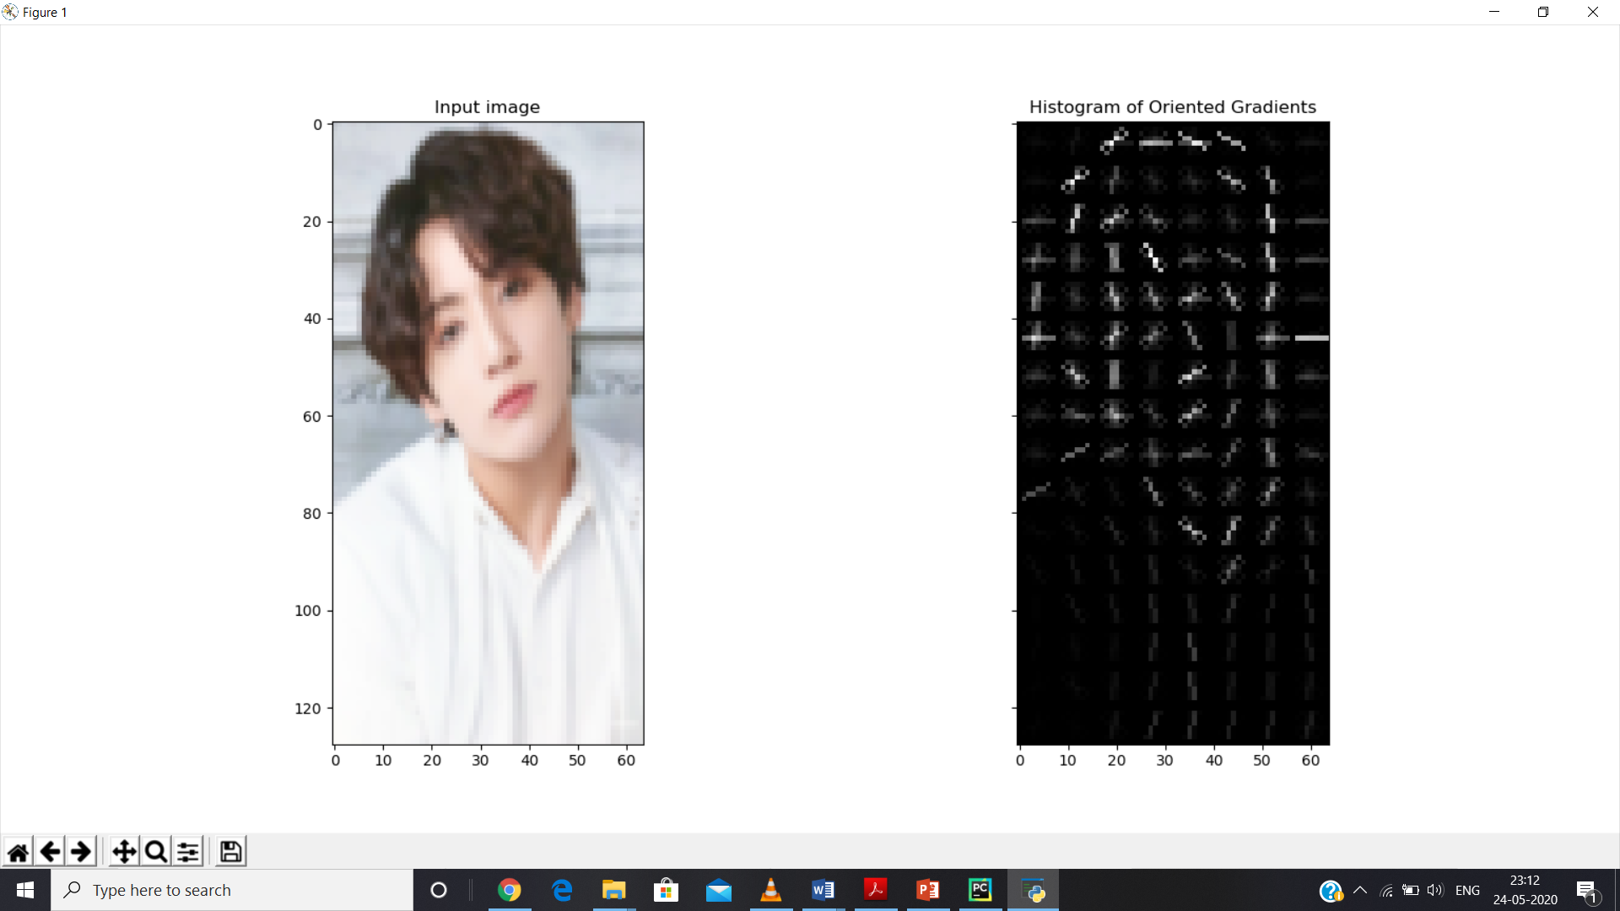

**Fig 3.2: HOG of an image**

To find faces in this HOG image, all we have to do is find the part of our image that looks the most similar to a known HOG pattern that was extracted from a bunch of other training faces.



**Fig 3.3: Code to find face in an image**

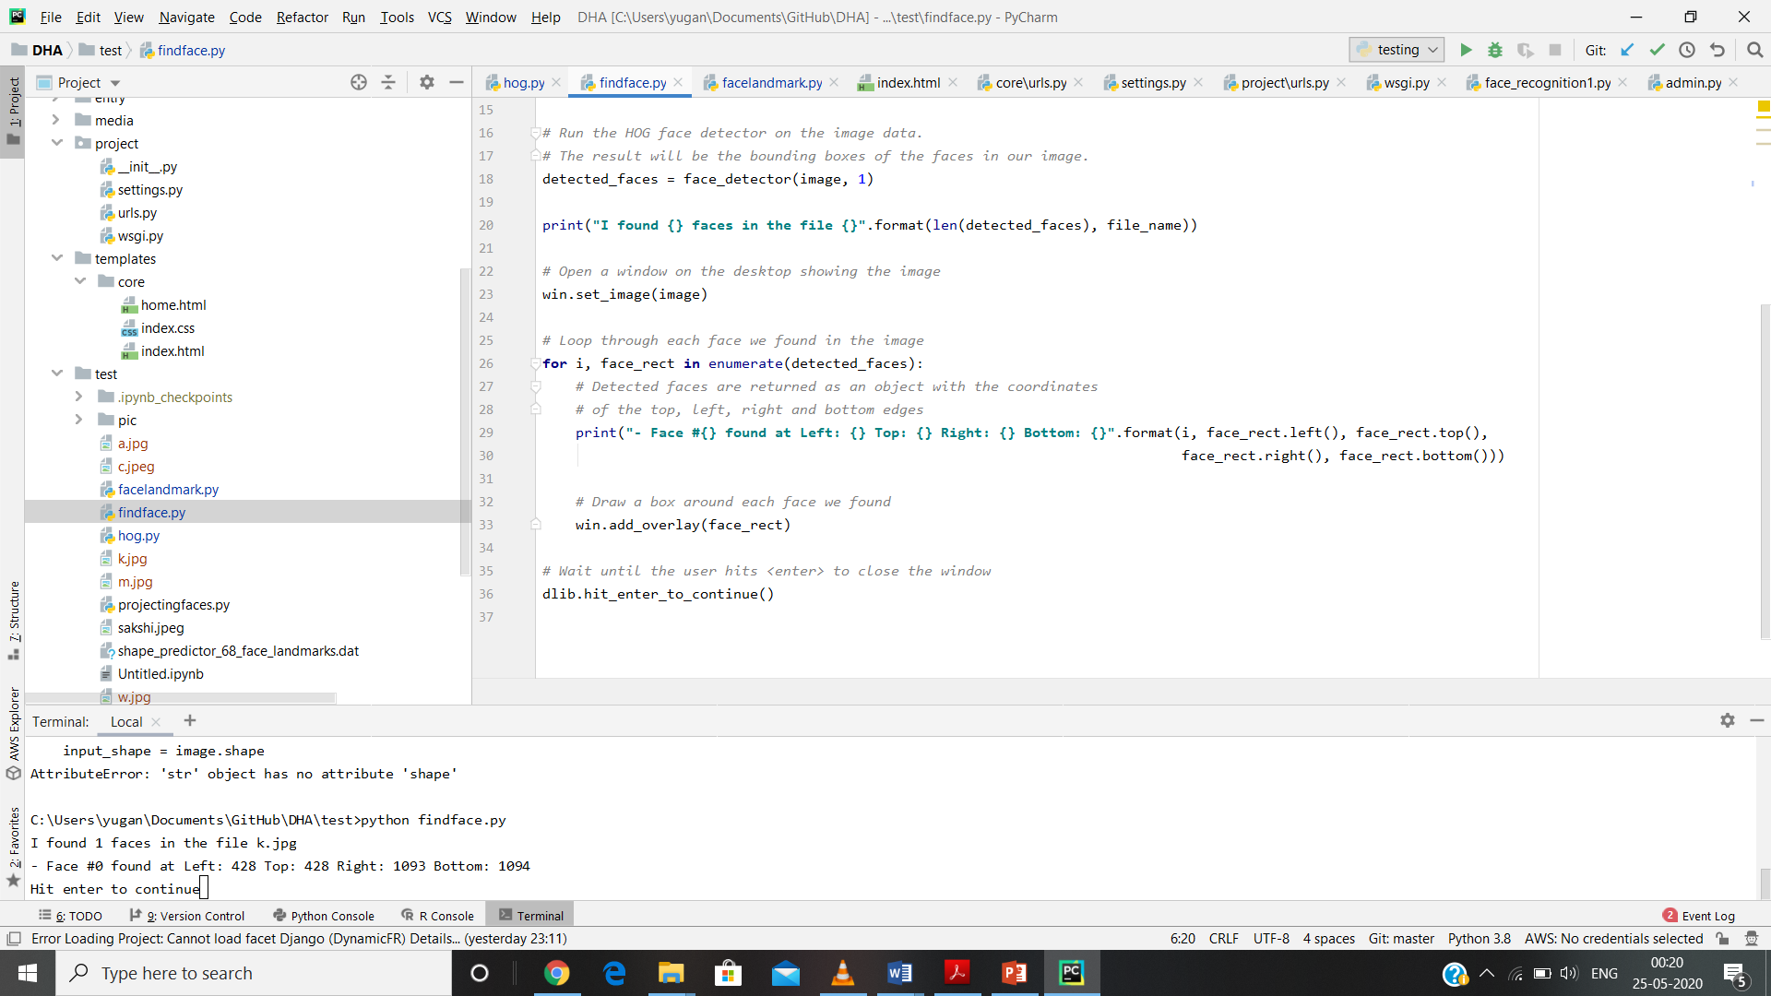

**Fig 3.4: Code to find face in an image (continued)**



**Fig 3.5: Face Detection**

Using this technique, we can now easily find faces in any image

**3.2.2 Posing and Projecting Faces**

We have isolated the faces in our image. But now we have to deal with the problem that faces turned different directions look totally different to a computer.



**Fig 3.6: Different poses of Jungkook**

Humans can easily recognize that the images are of Jungkook, but computers would see these pictures as completely different people.

To account for this, we will try to warp each picture so that the eyes and lips are always in the sample place in the image. This will make it a lot easier for us to compare faces in the next steps. To do this, we are going to use an algorithm called face landmark estimation.

The basic idea is we will come up with 68 specific points (called landmarks) that exist on every face — the top of the chin, the outside edge of each eye, the inner edge of each eyebrow, etc. Then we will train a machine learning algorithm to be able to find these 68 specific points on any face.

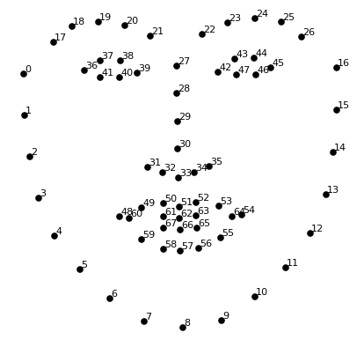

**Fig 3.7: Facial Landmarks**

Here’s the result of locating the 68 face landmarks on our test image.



**Fig 3.8: Facial landmark code**



**Fig 3.9: Facial landmark code (continued)**

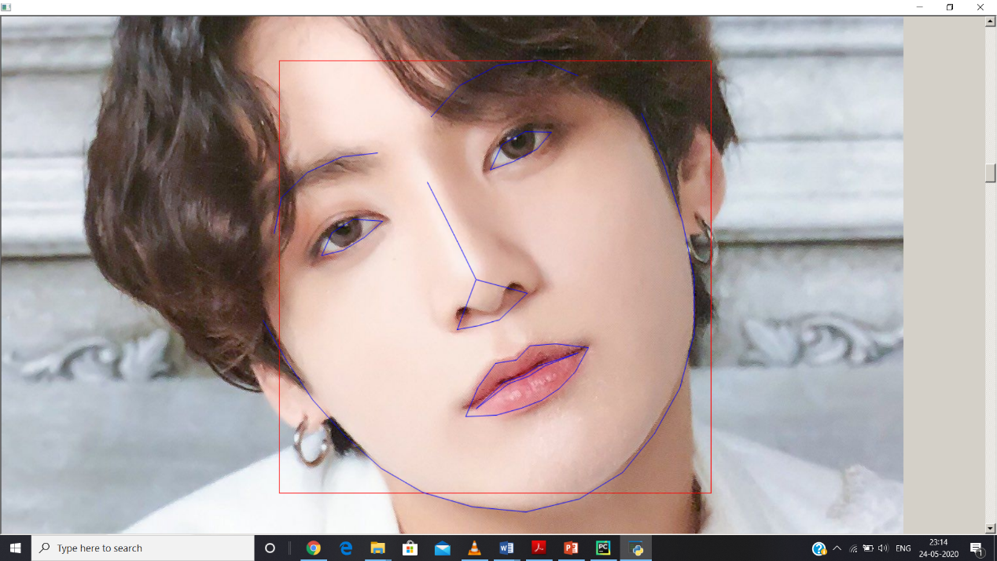

**Fig 3.10: Facial landmark on pic of Jungkook**

Now that we know where the eyes and mouth are, we’ll simply rotate, scale and shear the image so that the eyes and mouth are centered as best as possible. We won’t do any fancy 3d warps because that would introduce distortions into the image. We are only going to use basic image transformations like rotation and scaling.

The command used is the following:

*./util/align-dlib.py ./training-images/ align outerEyesAndNose ./aligned-images/ --size 96*

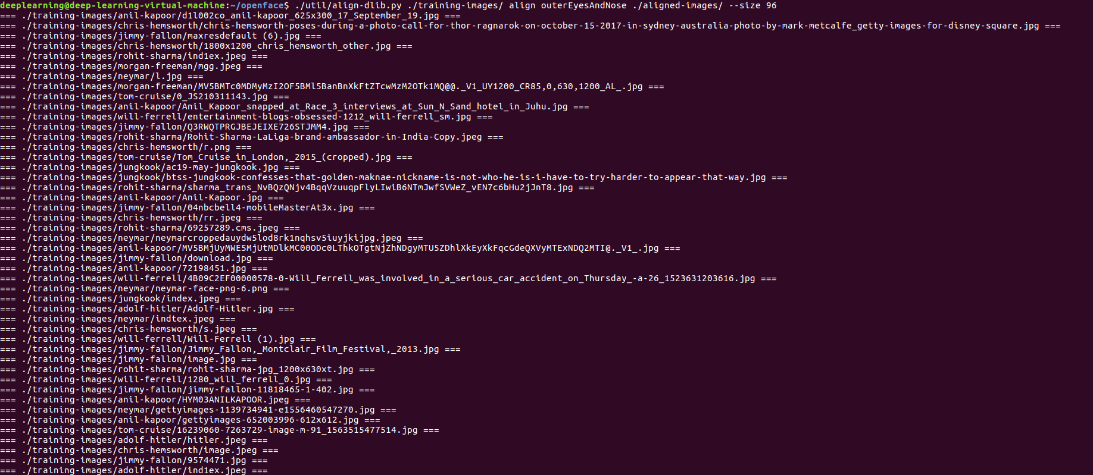

**Fig 3.11: Command line command to align images**

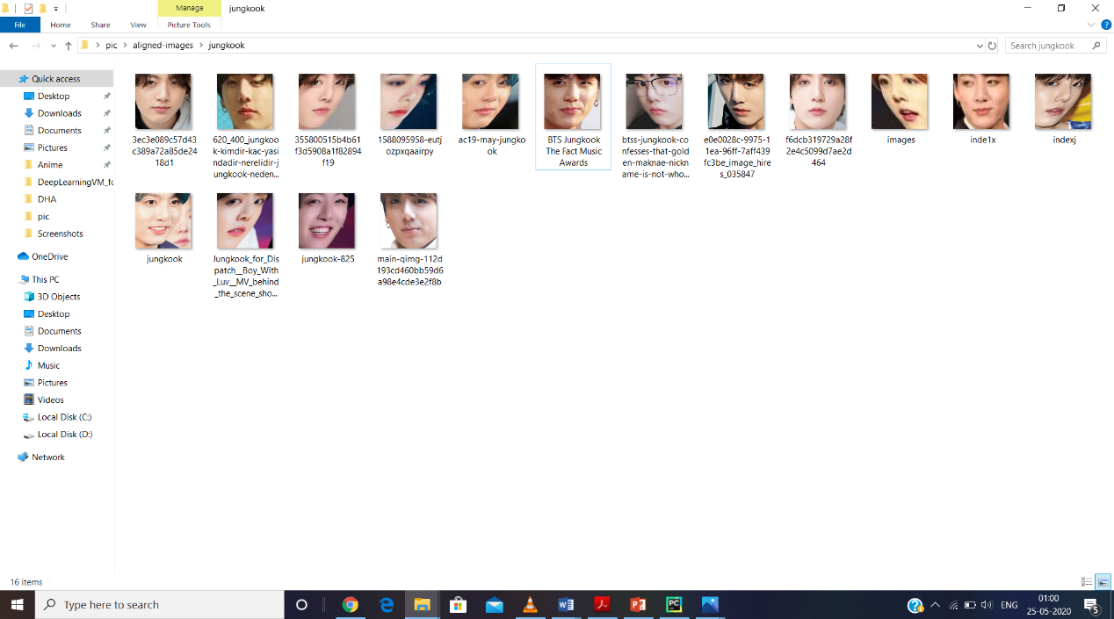

**Fig 3.12: Images in aligned folder**

This will create a new *./aligned-images/* subfolder with a cropped and aligned version of each of your test images.

 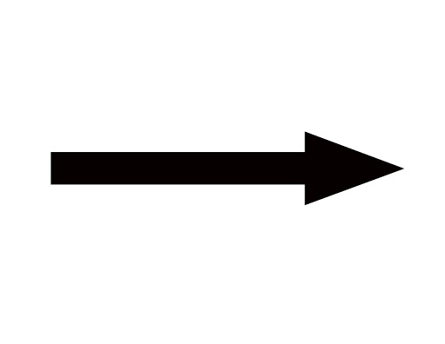 

**Fig 3.13: Image transformation**

Now no matter how the face is turned, we are able to center the eyes and mouth are in roughly the same position in the image. This will make our next step a lot more accurate.

**3.2.3 Encoding Faces**

Now we are to the meat of the problem — actually telling faces apart. This is where things get really interesting! The simplest approach to face recognition is to directly compare the unknown face we found in Step 2 with all the pictures we have of people that have already been tagged. When we find a previously tagged face that looks very similar to our unknown face, it must be the same person. Seems like a pretty good idea, right?

There’s actually a huge problem with that approach. A site with billions of users and a trillion photos can’t possibly loop through every previous-tagged face to compare it to every newly uploaded picture. That would take way too long. They need to be able to recognize faces in milliseconds, not hours. What we need is a way to extract a few basic measurements from each face. Then we could measure our unknown face the same way and find the known face with the closest measurements. For example, we might measure the size of each ear, the spacing between the eyes, the length of the nose, etc.

Ok, so which measurements should we collect from each face to build our known face database? Ear size? Nose length? Eye color? Something else?

It turns out that the measurements that seem obvious to us humans (like eye color) don’t really make sense to a computer looking at individual pixels in an image. Researchers have discovered that the most accurate approach is to let the computer figure out the measurements to collect itself. Deep learning does a better job than humans at figuring out which parts of a face are important to measure.

The solution is to train a Deep Convolutional Neural Network. But instead of training the network to recognize pictures objects like we did last time, we are going to train it to generate 128 measurements for each face.

The training process works by looking at 3 face images at a time:

* Load a training face image of a known person
* Load another picture of the same known person
* Load a picture of a totally different person

Then the algorithm looks at the measurements it is currently generating for each of those three images. It then tweaks the neural network slightly so that it makes sure the measurements it generates for #1 and #2 are slightly closer while making sure the measurements for #2 and #3 are slightly further apart.

After repeating this step millions of times for millions of images of thousands of different people, the neural network learns to reliably generate 128 measurements for each person. Any ten different pictures of the same person should give roughly the same measurements. Machine learning people call the 128 measurements of each face an embedding. The idea of reducing complicated raw data like a picture into a list of computer-generated numbers comes up a lot in machine learning.

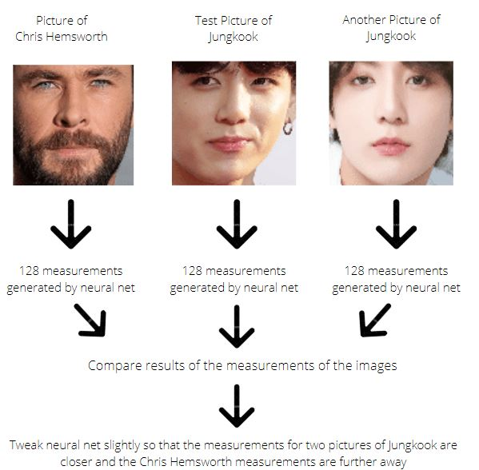

**Fig 3.14: Training Steps**

This process of training a convolutional neural network to output face embeddings requires a lot of data and computer power. Even with an expensive NVIDIA Telsa video card, it takes about 24 hours of continuous training to get good accuracy. But once the network has been trained, it can generate measurements for any face, even ones it has never seen before! So this step only needs to be done once. Lucky for us, the fine folks at OpenFace already did this and they published several trained networks which we can directly use. So all we need to do ourselves is run our face images through their pre-trained network to get the 128 measurements for each face.

We, generate the representations from the aligned images by the following command:

*./batch-represent/main.lua -outDir ./generated-embeddings/ -data ./aligned-images/*

After you run this, the ./generated-embeddings/ sub-folder will contain a csv file with the embeddings for each image.



**Fig 3.15: Command line code to generate embeddings**

The output of the following command is:



**Fig 3.16: labels.csv and reps.csv are created**

Labels.csv contains the image name and the path along with a serial number.



**Fig 3.17: labels.csv contents**

Reps.csv contains the 128 measurements generated by the image.

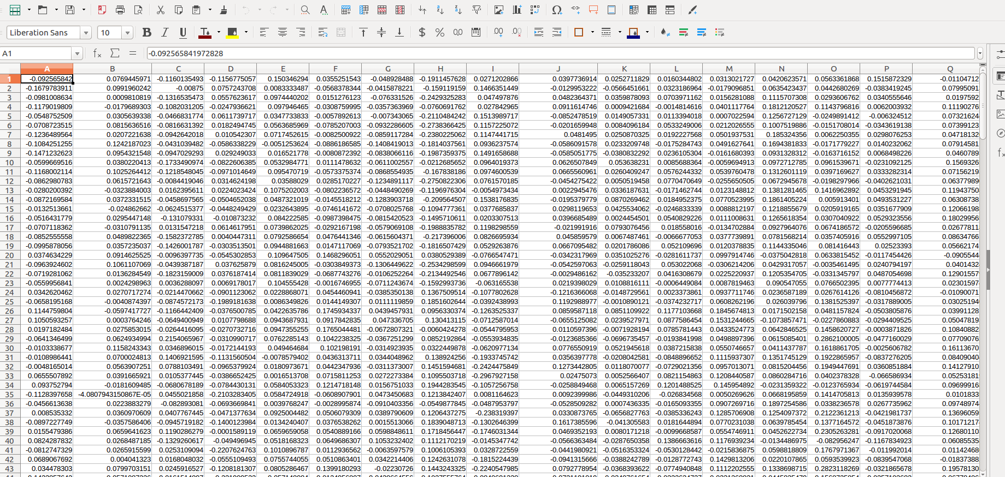

**Fig 3.18: reps.csv contents**

**3.2.4 Finding the name of the person**

This last step is actually the easiest step in the whole process. All we have to do is find the person in our database of known people who has the closest measurements to our test image. We can do that by using any basic machine learning classification algorithm. No fancy deep learning tricks are needed. We’ll use a simple linear SVM classifier, but lots of classification algorithms could work. All we need to do is train a classifier that can take in the measurements from a new test image and tells which known person is the closest match. Running this classifier takes milliseconds. The result of the classifier is the name of the person!

We train our face detection model by the following command:

*./demos/classifier.py train ./generated-embeddings/*



**Fig 3.19: Command line to generate model**

This will generate a new file called *./generated-embeddings/classifier.pkl.* This file has the SVM model you'll use to recognize new faces.

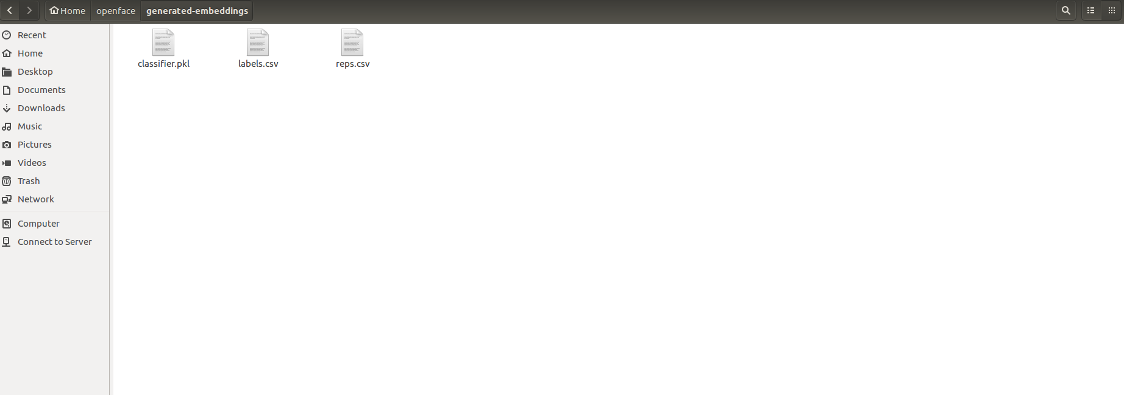

**Fig 3.20: classifier.pkl generated**

**3.2.5 Testing**

We take a new picture with an unknown face. Pass it to the classifier script like this:

*./demos/classifier.py infer ./generated-embeddings/classifier.pkl your_test_image.jpg*

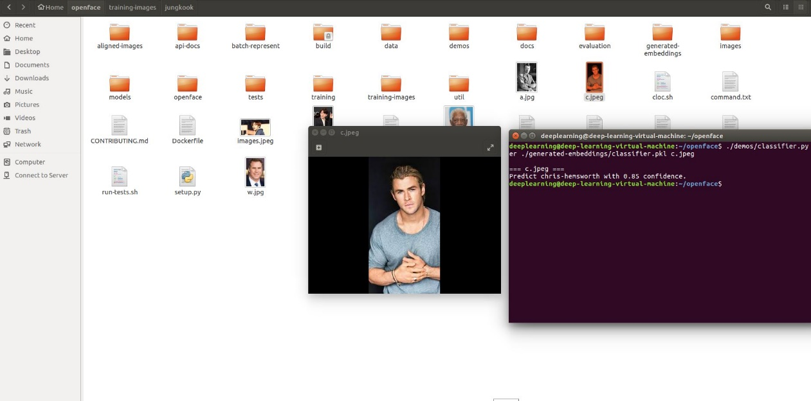

**Fig 3.21: Testing on Chris Hemsworth**

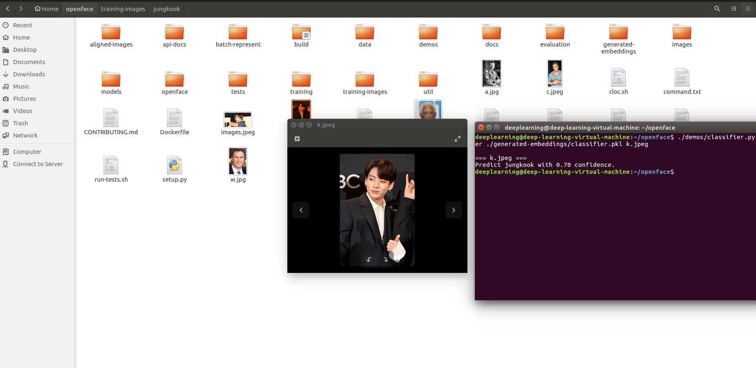

**Fig 3.22: Testing on Jungkook**

Let’s review the steps we followed:

1. Encode a picture using the HOG algorithm to create a simplified version of the image. Using this simplified image, find the part of the image that most looks like a generic HOG encoding of a face.
2. Figure out the pose of the face by finding the main landmarks in the face. Once we find those landmarks, use them to warp the image so that the eyes and mouth are centered.
3. Pass the centered face image through a neural network that knows how to measure features of the face. Save those 128 measurements.
4. Looking at all the faces we’ve measured in the past, see which person has the closest measurements to our face’s measurements. That’s our match!

**3.3 WEB DEPLOYMENT**

**3.3.1 Model/Schema**



**Fig 3.23: models.py file**

The model has major 3 components:

1. Person – Person name, user id, email and pic are the details of the person class. A person will have the four mentioned properties which will be used to uniquely identify an individual.
2. Station – Station number, station name are the details of the station class. A station will have the two mentioned properties which will be used to uniquely identify a station.
3. Logs – Log is an official record of the events that happen during the transaction. When a person enters in a station, their face is recorded by the camera and an entry is created in the database. The entry will contain user id, person name, entry station name, entry station number, entry image and will be filled. Details like exit station name, exit station number, exit image will be Null in the beginning. When that person exits a station then those details are filled and the log entry is filled completely and the person status will be set to true which means that the person has exited through a station and will now receive a mail of their travel.



**Fig 3.24: Mail of the traveler travel history**

The admin panel is created in django with having three core entries – Logs, Persons and Stations as specified in the database model schema



**Fig 3.25: Core in admin panel**



**Fig 3.26: Station tab in admin panel**



**Fig 3.27: Persons tab in admin panel**

** Fig 3.28: Logs tab in admin panel**

**3.3.2 Frontend**

Frontend is developed using html and css.



**Fig 3.29: Frontend**



**Fig 3.30: Frontend Code**

**3.3.3 Backend**

Views.py is the file in which the backend work is done. It links the frontend, backend and database and does face recognition.



**Fig 3.31: views.py code**



**Fig 3.32: views.py code (continued)**



**Fig 3.33: views.py code (continued)**

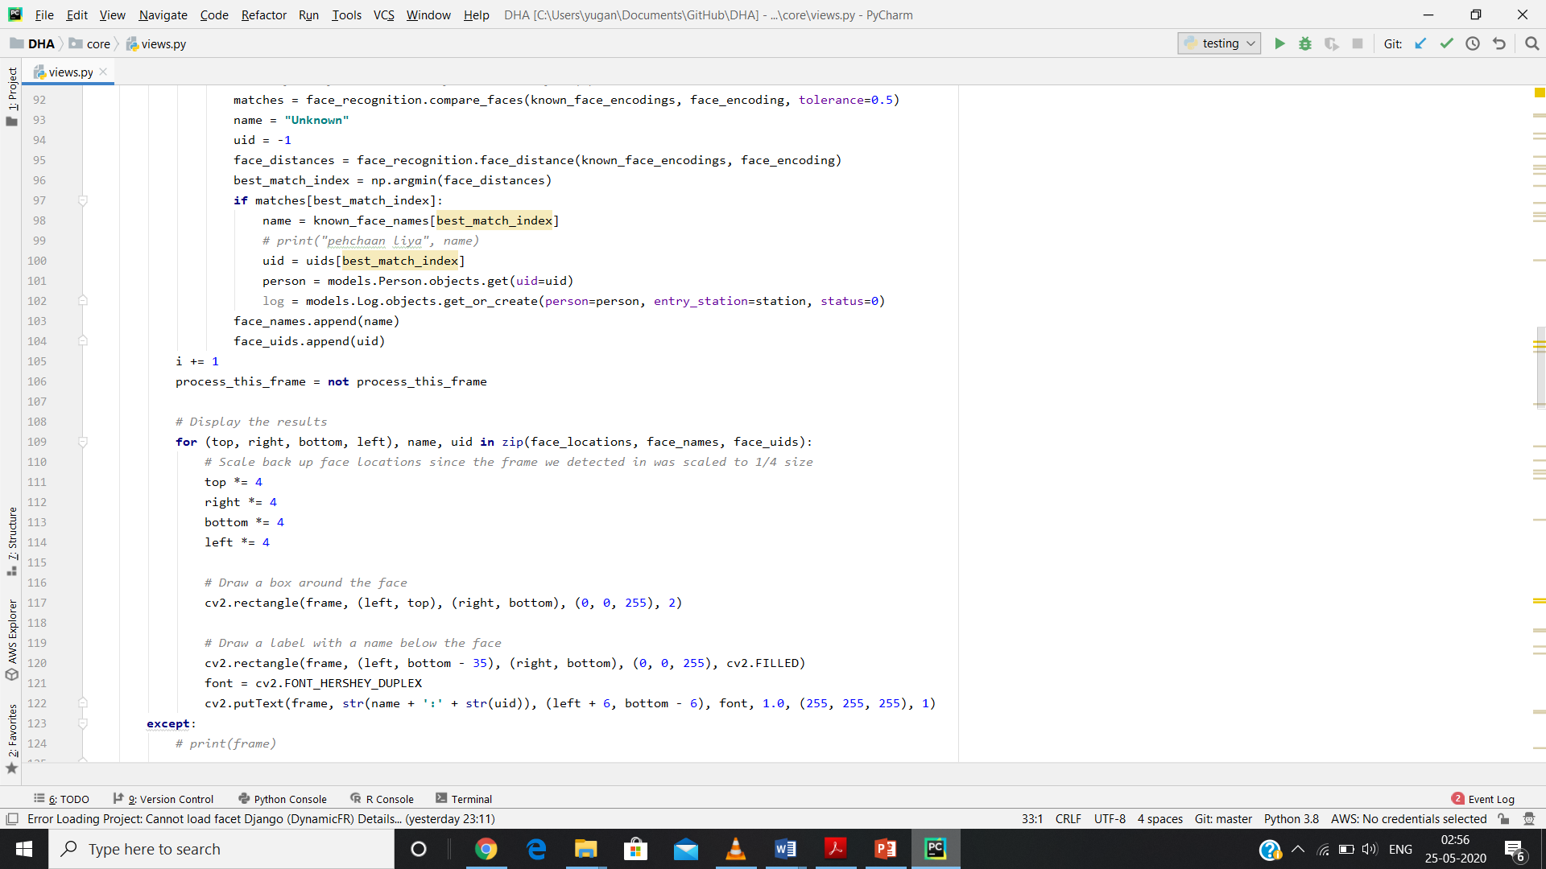

**Fig 3.34: views.py code (continued)**

** Fig 3.35: views.py code (continued)**



**Fig 3.36: views.py code (continued)**

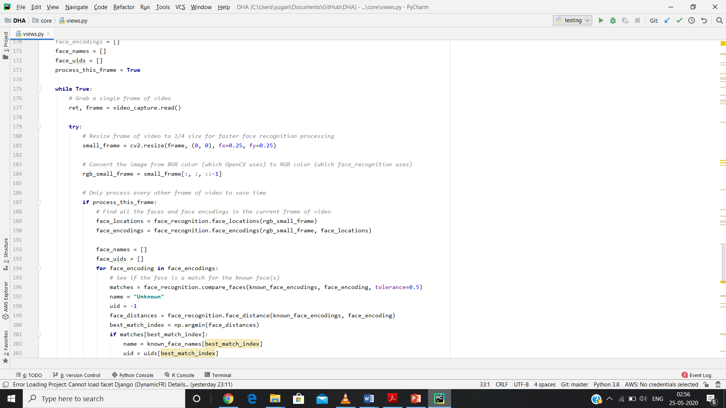 **Fig 3.37: views.py code (continued)**

** Fig 3.38: views.py code (continued)**

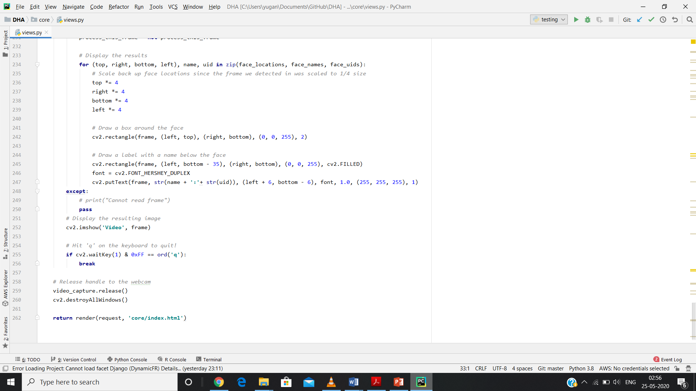

**Fig 3.39: views.py code (continued)**

**CHAPTER 4: HARDWARE AND SOFTWARE REQUIREMENTS**

Hardware and software requirements of any project are must to be satisfied, so that the virtual environment can be set up on any machine to run the project. So in this section the software and the hardware requirements are discussed completely.

**4.1 HARDWARE REQUIREMENTS**

The program can run on a machine with following configurations:

1. Windows 10 Operating system/ Linux/ Ubuntu
2. Nvidia Graphic card
3. Ram>4gb
4. Webcam

**4.2 SOFTWARE REQUIREMENTS**

The project involves a use of lot of software.

1. Python 3.7- the python version used in this project is the version 3.7, with python libraries like dlib, opencv etc.
2. Django – Django must be installed in the machine in order to run the project as the backend is build in Django.
3. Annaconda: Annaconda can be used as a python compiler for writing the python code. It also provides and IDE.
4. Github: it is used to collect all the file and make a repository.

**CHAPTER 5: RESULTS**

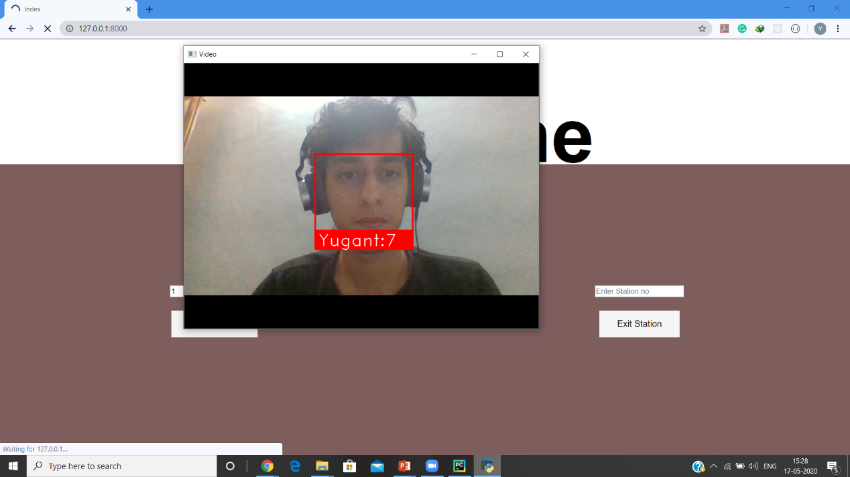

**Fig 5.1: Face Recognition**

Face is recognized and as a result the person name and user id is displayed in the camera window.



**Fig 5.2: Frontend implementation**

Above pic shows how the frontend looks when the project is executed.



**Fig 5.3: Backend implementation**

Above shows how the backend looks when the project is executed.



**Fig 5.4: Mail sent to the traveler after their travel**

**CHAPTER 6: CONCLUSION**

With the completion of this project, we have successfully achieved our objective to

Dynamically authenticate humans and make travel a bit optimal.

With this project the the traveler will be recognized as the camera scans their face and shows whether the person is a registered user or not. Face recognition is implemented with Django in this project handling data and python modules and libraries

The project can be merged with IOT to implement many other features and can use paid api in order to make complex tasks much easier

To conclude, we have learnt a lot of things working under this project. We are also

thankful to our mentor and supervisor for their efforts in the learning process.

**CHAPTER 7: REFERENCES**

<https://www.udemy.com/course/python-for-computer-vision-with-opencv-and-deep-learning/>

<https://www.udemy.com/course/computer-vision-a-z/>

<https://medium.com/@ageitgey/machine-learning-is-fun-part-4-modern-face-recognition-with-deep-learning-c3cffc121d78>

<https://cmusatyalab.github.io/openface/#overview>

**BRIEF PROFILE OF STUDENT**

**Name :** Yugant Kachroo 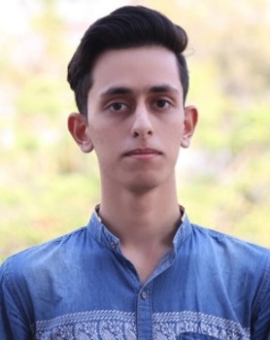

**Roll No :** 17001003064

**Branch :** Computer Engineering

**Email Id :** [yugant35@gmail.com](mailto:yugant35@gmail.com)

**Brief About Project:**

This project revolved around the usage of face recognition in order to make ticketing system paperless and efficient. Here we detected faces dynamically and recognized the person with registered users with automatic ticket issuing.

**Future Scope**

The project can be merged with IOT to implement many other features and can use paid api in order to make complex tasks much easier